Testing plan: Coursework 17/18 step 2

Designed and executed by B00329768 Mikolaj Lukasik on 13/04/2018.

Table of Contents

1. Batch pickled file creation 2

2. Components pickled files creation 2

3. Batch non-existence safe switch 2

4. Proper display of all batches 3

5. Details of a batch display 3

6. Details of a component display 5

# Batch pickled file creation

## Expected result:

After batch creation, program should save all batch information in a pickled file in Data/Batches directory.

## Actual result:

File created.

## Screenshots:

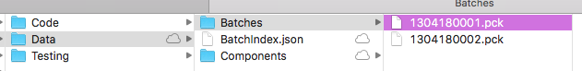

# Components pickled files creation

## Expected result:

After batch creation, program should save all component information in pickled files in Data/Components directory.

## Actual result:

Files created.

## Screenshots:

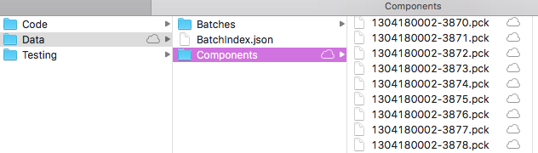

# Batch non-existence safe switch

## Expected result:

Any option except 1 (Create a new batch.) should not be executed unless the user first created some batches.

## Actual result:

All menu functions, when selected without any batches created, inform users that “There are no batches yet.”

## Screenshots:

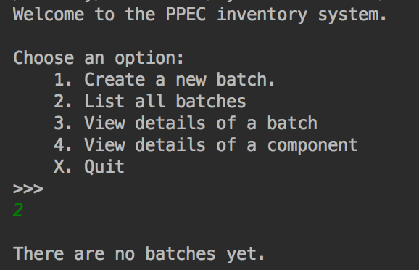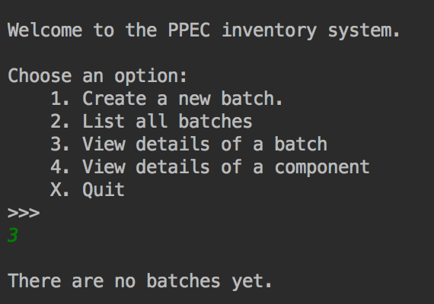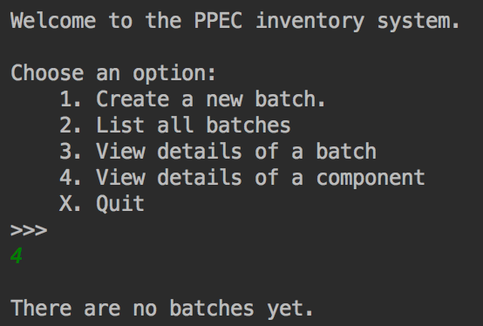

# Proper display of all batches

## Expected result:

When 2nd option is selected, and user have created some batches earlier, program displays short info about them.

## Actual result:

Program display batch ID, number of components, manufacture date, type and subtype of component and current location neatly for all the batches.

## Screenshots:

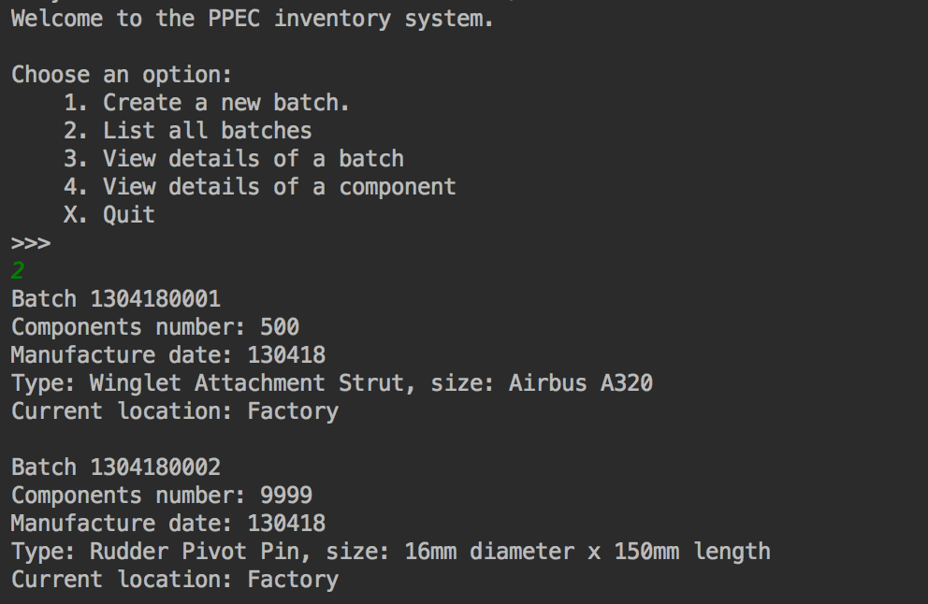

# Details of a batch display

## Expected result:

Selecting 3rd option and providing the correct batch number will display details of the batch with full listing of all its components.

## Actual result:

On correct batch ID provided by user, program display batch ID, number of components, manufacture date, and current location of the batch, then proceeds to list detailed information about all its components. (ss1)

Incorrect batch ID, including all alphanumeric or multisymbolic input will result in error message. (ss2)

User can also go back to main menu simply selecting X. (ss3)

## Screenshots:

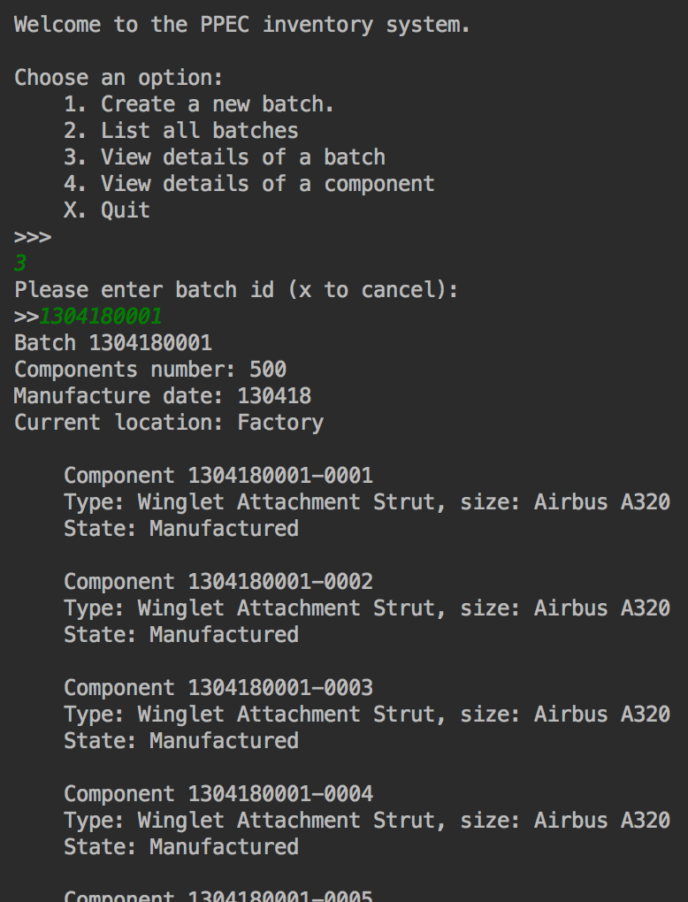

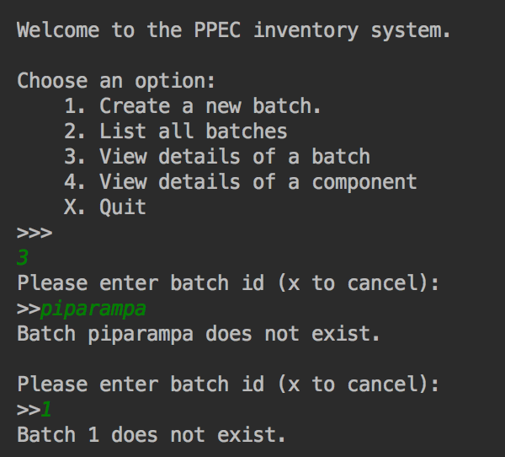

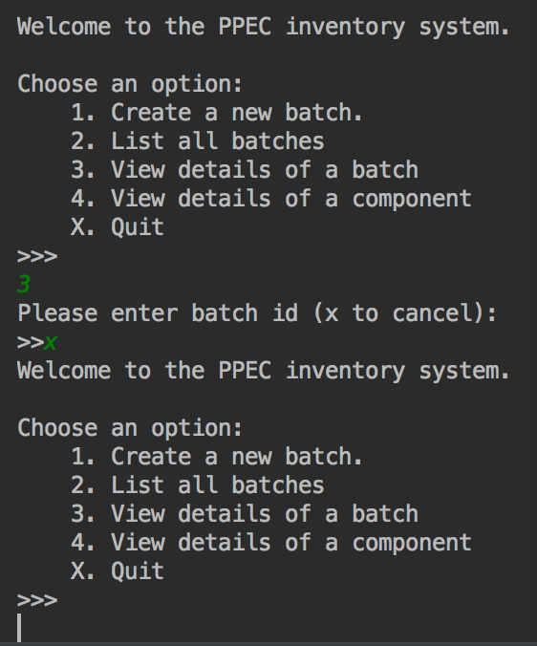

# Details of a component display

## Expected result:

Selecting 4th option and providing the correct component number will display details of the specific component.

## Actual result:

On correct component ID provided by user, program display component ID, type and subtype of component, and its state. (ss1)

Incorrect component ID, including all alphanumeric or multisymbolic input will result in error message. (ss2)

User can also go back to main menu simply selecting X. (ss3)

## Screenshots:

